Project Design Phase-II
Data Flow Diagram & User Stories

Date | 07 July 2026
Team ID
Project Name | Cosmetic Insights: Navigating Cosmetics Trends and Consumer Insights with Tableau
Maximum Marks | 4 Marks

Data Flow Diagrams:
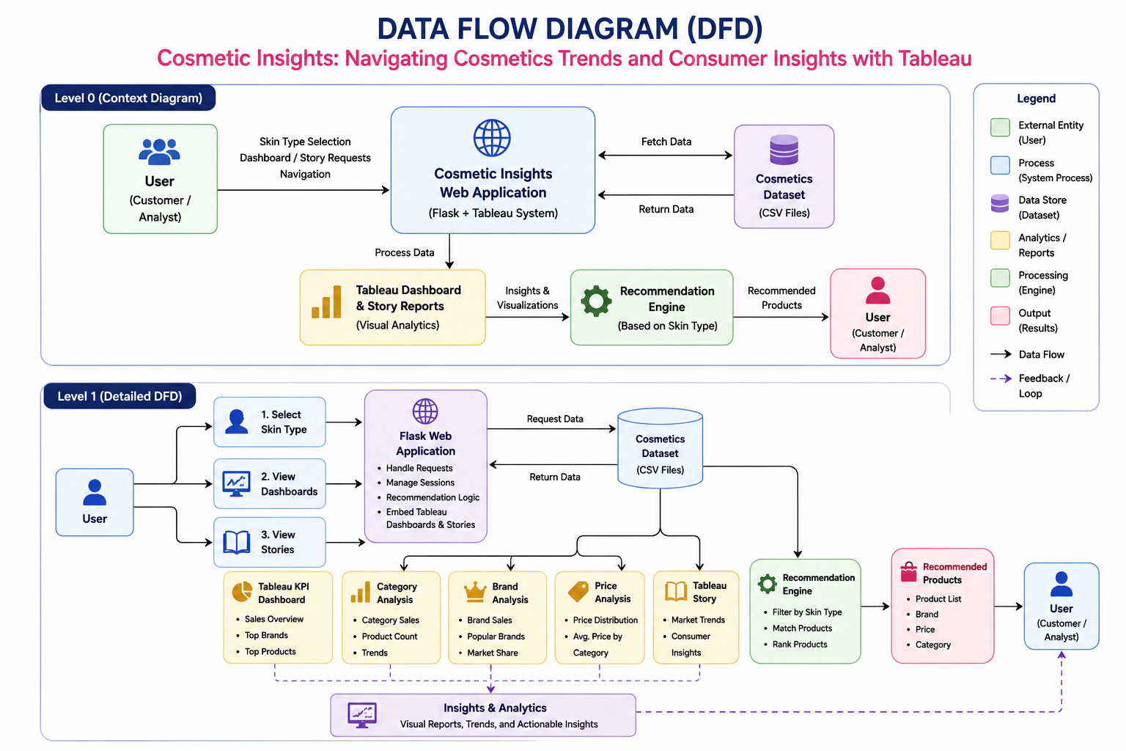

User Stories
US-01 | Cosmetics Customer | Select my skin type | I can receive personalized cosmetic product recommendations
US-02 | Cosmetics Customer | Browse cosmetic products by category | I can easily find products that match my needs
US-03 | Cosmetics Customer | Compare cosmetic brands | I can choose the most suitable brand
US-04 | Cosmetics Customer | Compare product prices | I can make cost-effective purchasing decisions
US-05 | Cosmetics Customer | View top-rated brands and products | I can identify trusted cosmetic products
US-06 | Beauty Enthusiast | Explore cosmetic trends | I can stay updated with market insights
US-07 | Beauty Enthusiast | View Tableau stories | I can understand insights through visual storytelling
US-08 | Business Analyst | Analyze product distribution by category | I can understand market demand patterns
US-09 | Business Analyst | Analyze skin-type coverage | I can identify products suitable for different skin types
US-10 | Business Analyst | View brand performance dashboards | I can evaluate brand popularity and product availability
US-11 | Business Analyst | Analyze price distribution | I can understand pricing strategies across brands
US-12 | Website Visitor | Access dashboards, stories, and recommendations from one platform | I can get all insights without switching applications
US-13 | Website Visitor | Navigate easily through the website | I can quickly find the information I need
US-14 | Project Admin | Embed Tableau dashboards and stories into the website | Users can access visual analytics directly

